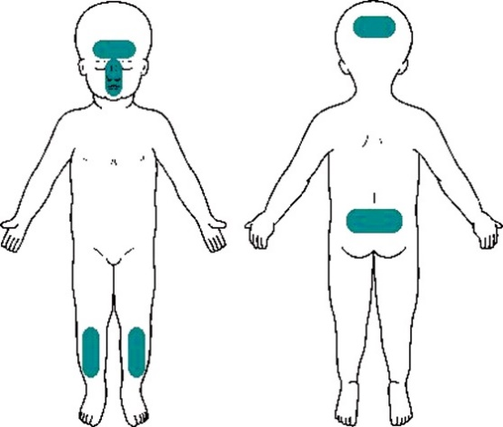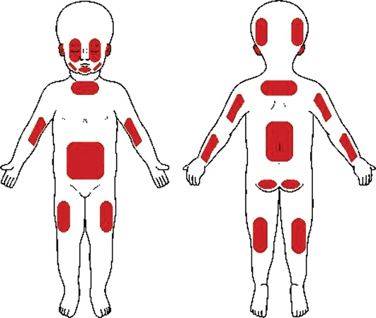

Sites of accidental injuries. Core Info: Evidence base for medical aspects of child abuse: systematic reviews of literature on child abuse and accidental injuries.

Sites of non-accidental injuries (Core Info)

NB: any bruising or unexplained sub-conjunctival haemorrhages in non-mobile children always raises concern & warrants a referral via FDFFs the same day

Document the name of the person you spoke with and the response you received.

If child has current injury, information will be passed immediately to Duty Practice Manager or Team Manager if the Practice Manager is unavailable.

**YES**

Happy with response?

**NO**

Follow up ALL referrals, in writing, in 24 hours.

**If still unhappy…**

* Ask to speak to a SW manager. In the out of hours situation EDS have the Senior Manager on call rota details.
* Call 999 and ask for the Police to attend if the concern is that the child is in immediate danger e.g. angry/violent carer who is not co-operating with advice/concern.

Ask for clarity about decision, e.g. “why are you not coming to see this child?”

**NOTE:** FDFF/EDS – responsible for liaising with paediatricians and police regarding a Child Protection medical and are also responsible for organising transport.

**NOTE:** If return call is not within an appropriate time frame i.e. 30 minutes, document this AND give feedback to Social Services ASAP, as part of ongoing review of EDS service.

**If you believe a child to be at immediate risk of harm, call the POLICE.** If not, the FIRST action should always be to make a referral.

Contact FDFFs, or Emergency Duty Service (EDS).

**FDFF** – (01273) 290400

* 9-5 Monday-Thursday, 9-4:30 Friday

Relay detail of concerns and your return contact details to Social Work contact.

**EDS** – (01273) 335905/6

* Outside of FDFF opening hours may be voicemail. Leave a message with concerns and your return contact details.